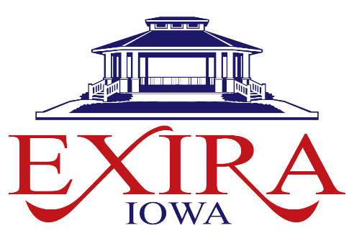

108 E WASHINGTON STREET
PO BOX 187
EXIRA, IOWA 50076
712-268-2187
EXIRACLK@METC.NET

UTILITY ACCOUNT CLOSURE REQUEST
Date of request: ____________________________________________________
Account number: __________________________________________________
Name on account: _________________________________________________
Address for account you want to close: _______________________________
Phone number: ____________________________________________________
Forwarding address: _______________________________________________
Reason for account closure: SOLD HOME MOVING OTHER
Are you a tenant? YES NO
Do you have a garbage can to be picked up? YES NO
Statement of Understanding:
Final Bill is for usage: _________________through ________________
and billed on _____________ due ______________
Signature: ___________________________________ Date: ______________
This form must be completed and returned to City Hall.
Missing information may cause delay in account closure and result in continued billing.

